Create a dockerfile, file which when build must display your basic details in website.

**Solution:-**

Created Dockerfile and index.html file

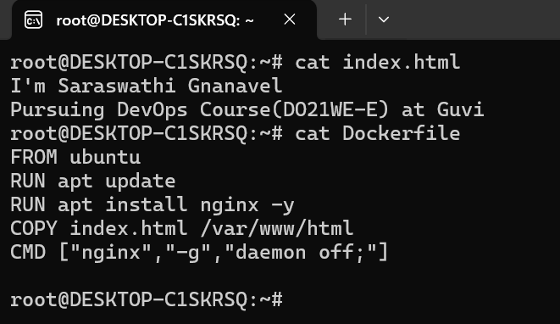

Building the Docker image

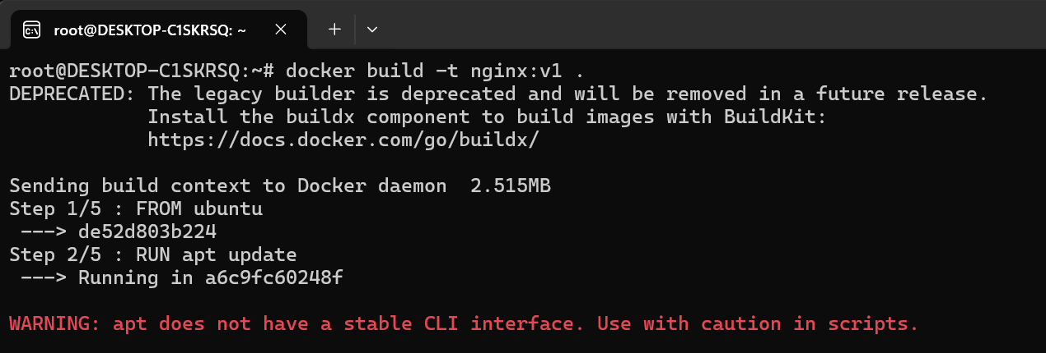

Docker Image has been built successfully

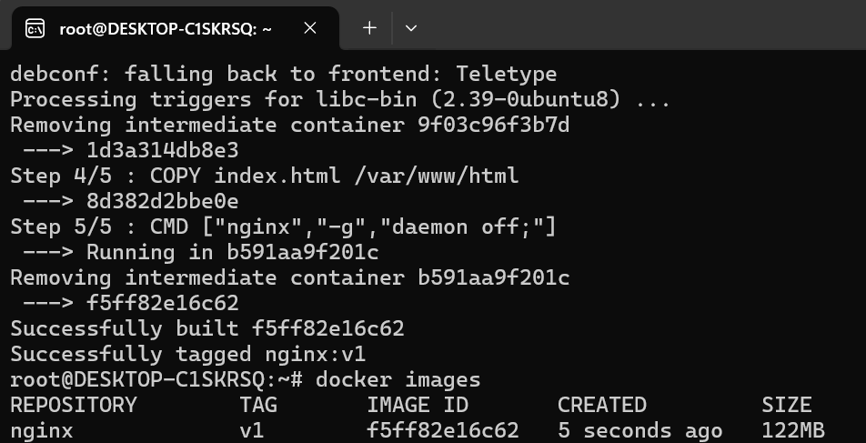

Running the Docker Container

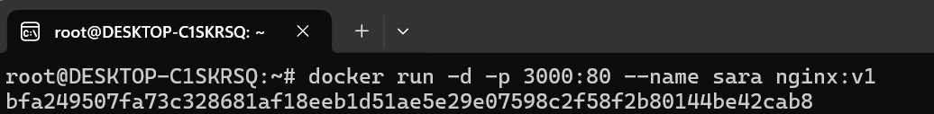

Container is running

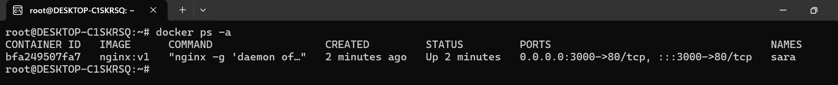

Expected output is displaying in the website

